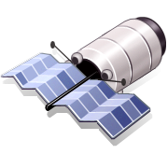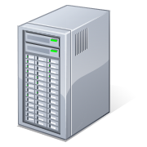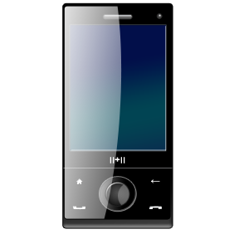



I

N

T

E

R

F

A

C

E

Collect Data

Parse Data

XML Request

XML Response

S

E

R

V

E

R

action

result

collect

view

send

receive

SOAP request

SOAP response

Mobile phone

Server

GPS Satellite

Mengirimkan data lokasi

Mengembalikan data

Memetakan posisi